,Name: _______________________ Date: ____________ Period: _________

My Measurements
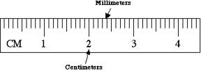
Measurement | Length or Circumference (mm) | Length or Circumference (cm)
Around the base of my thumb
Around my wrist
Around my neck
Around my waist
Top of my head to the base of my skull
Width of my head
Width of my shoulders
Length of my upper arm, elbow to
shoulder
Length of my forearm, elbow to wrist
Length of my head to my navel (belly -button)
Top of head to tip of fingers, arms at
sides
Pupil of eye to outside corner of mouth
Upper lip to bottom of chin
Width of nose
Distance between eye and eyebrow
Width of eye
Distance between nostrils
Width of right hand
Width of left hand
Length of my shoe
Width of my shoe
Top of knee to bottom of heel
Your choice:
Your choice:
Your choice:

